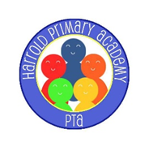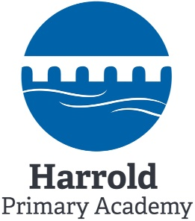PTA Newsletter

November 2019

harroldprimaryacademy.pta@gmail.com



Dear Parents & Carers,

The PTA would like to thank each and every one of you for your continued support towards our fundraising events held this term. The events have all been well attended and the children have enjoyed participating. We continue to focus on raising funds for “Project Playground” along with all the regular events and activities funded by the PTA. Without your help and support, this would not be possible. We are now in the process of collecting quotes for the play equipment suggested by the Student Council. We look forward to seeing you all at our next big event, The Harrold Frost Fair, to be held at the Harrold Centre on Sunday 1st December between 12.30 and 3.30pm.

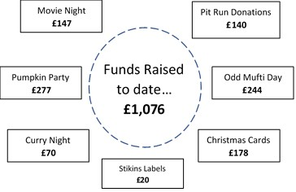

**Easyfundraising:** Raised £43.09 in the last 30 days! Thank you to all those already registered. If not yet signed up, please do so before you start your **Christmas Shopping** and with **Black Friday** looming, there are lots of donations that could be made. All you have to do is find the retailer you want to shop with on the easyfundraising website or App, shop as usual and the retailer will donate to us when you make a purchase – at no extra cost to you! This means you can support the school when you do your **grocery shopping**, **bookings @ booking.com** or days out, **order takeaways**, buy things for the kids, or even when you **renew your insurance and energy policies**.

<https://www.easyfundraising.org.uk/causes/harroldprimaryacademy/>

**Amazon Smile**

AmazonSmile is an easy way to support Harrold Primary Academy PTA every time you shop. When you shop at [smile.amazon.co.uk](https://smile.amazon.co.uk), you’ll find the same low prices and vast selection as amazon.co.uk, with the added bonus that Amazon will donate a portion of the purchase price. On your first visit, select Harrold Primary Academy PTA as your chosen charity before you begin shopping. Amazon will then donate 0.5% of the net purchase price.



**Film Night** – Secret Life of Pets 2 was thoroughly enjoyed by the children along with their popcorn.



**Santa’s Grotto**

Father Christmas and his elves will be coming to Harrold soon! He'll have a grotto at the Harrold Centre on the 1st December. Bookings can be made on the day - £3 per child, with discounts for families and includes a present for each child.

**Pumpkin Party** – An absolute blast! A big thank you to everyone that attended. A lot of song and dance by one and all. Our thanks to Tesco’s and Sainsbury’s for their donations.



**Curry Night** – Thanks go to Spices of Paradise and the parents who attended. Memorable night for all.

On behalf of all of us on the PTA committee, we would like to wish you all a very Merry Christmas and a Happy New Year!



Come along and do your Christmas shopping from a variety of stalls at the fair. Reindeer food, yucky dip, face painting, cakes and mulled wine also available. Local Harrold products include the calendar, Christmas Cards and a large Harrold Print as well as handmade items from the Scouts and some lovely fresh mistletoe.

**Real Christmas Trees**

Merri Flowers, Oakley, have nominated HPA PTA as one of their charities. For every real tree bought from them, they will donate £5 per tree sold. Please see their attached leaflet for instructions to purchase. [www.merriflowers.co.uk](http://www.merriflowers.co.uk)