Design and Technology (D.T.)   | Cooking and Nutrition – Preparing Fruit and Vegetables  The children will be focusing on foods grown in the local area in the 'farm to fork' cooking and nutrition unit. They will design, make and evaluate a healthy snack made from fruits and vegetables alongside learning and practising the skills of peeling, grating and chopping.
Physical Education  (P.E.)   | Gymnastics  Children will practice rolls, balances and movement and explore how they can link these fluently.  Team Building  Children will learn how to be a good team member, and how effective they can be when working for the good of the team.  Ball Skills  Children will focus on how to use their hands successfully when dribbling, passing and receiving, working towards scoring a goal.  Dance  Children will respond to the stimulus of ‘water’ to create dynamic movement in small groups, individually, and as a whole class.
Computing   | Computing Systems and Networks  As part of this topic, the children will develop their understanding of technology and how information technology (IT) can be used for good in our lives.
Music   | Hands, Feet, Heart  The children learn about South African music. Children learn about the pulse, rhythm and pitch of music through learning to play instruments and singing.
Personal Social Health Education (P.S.H.E.)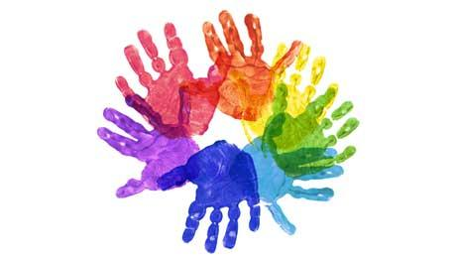 | My Emotions  This unit will help develop children’s understanding of their own emotions and those of others. They will identify a range of basic emotions, developing a language to describe them and considering what might cause different feelings in themselves and others. They will also consider ways to deal with different emotions and will consider their personal networks, identifying who they can talk to about their feelings.  Anti-Bullying  In this unit, children will develop their understanding of the key characteristics of bullying. They will explore and apply definitions of bullying to a range of situations including cyberbullying. Children will consider the feelings of others who are being bullied, those that witness bullying and those who bully others. They will also explore how the behaviour and response of bystanders can improve or worsen a situation.  The theme of anti-bullying will be addressed throughout the year, but with a particular focus during Anti-Bullying Week (Monday 13th - Friday 17th November).
World Views   | Stories in the Old Testament  The stories that the children will encounter in this unit are not only foundational within Christianity, Judaism and Islam, but are also important cultural stories. We will hear the stories and investigate what we can learn from them about life and belief at the time they were written. We will also think about what we can learn from them that’s still important today.  What gifts did Jesus get at Christmas?  We will look at the Christian Christmas story to find out who came to visit the baby Jesus and why the gifts they brought the new-born baby were so different to gifts we might give to a baby today. As part of this, we will investigate the jobs and importance of several different people in society – shepherds, doctors and vicars.
Enrichment  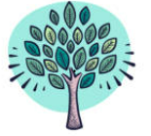 | If you have any expertise relating to any of our units of learning and would be interested in sharing them with the children, please contact the school office.
 | This half-term, the children will develop their growth mindset. This will lead to a desire to learn and therefore a tendency to embrace challenges, persist in the face of setbacks, see effort as the path to mastery, learn from criticism and find lessons and inspiration in the success of others. We promote this positive attitude to learning across the curriculum.  This overview gives an outline of the Year 2 Autumn Term curriculum.
English  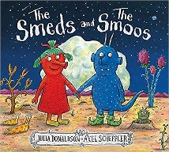 | In English, we will be exploring a range of texts to inspire fiction and non-fiction writing. First, they will develop and apply their phonics knowledge to write labels, lists and captions about themselves. Later in the term, they will explore and innovate some of Julia Donaldson's books, write instructions linked to D.T. and study rhyme in Michael Rosen's poetry. Focus texts include ‘The Day the Crayons Quit” by Oliver Jeffers and “The Smeds and the Smoos” by Julia Donaldson.
Maths  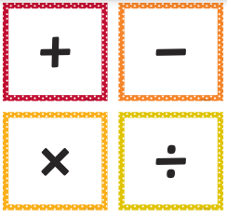 | Year 2  The children will consolidate and build upon their understanding of place value in numbers up to 100. They will then learn to add and subtract numbers including exchanging one 10 for ten 1s. They will also explore statistics and begin to learn their 2, 5 and 10 times tables.
Science  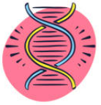 | Living Things  Children will compare living and dead objects through close observation, and explore the natural environment of the school grounds. They will consider things which were once alive by observing a cut flower over time. Children will also be able to describe how animals obtain food using food chains, and describe what different animals eat.  Plants  Children will learn to name a variety of common wildflowers and garden plants, and describe the basic structure of these. They will also explore a variety of evergreen and deciduous trees using sources to research these. Children will present their findings using scientific observational drawings in a horticultural booklet.
History  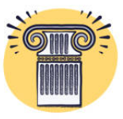 | Changes in our Local Area – How has our street changed over the last century?  In History, the children will be exploring our local history. They will investigate how it has changed in different ways from transport to the high street. The children will study photographs from the past to help develop their understanding of evidence and build their concept of chronology. Finally, they will go out and explore the local area on a walking tour, looking at some of the significant buildings and sites.
Geography   | Our World and Me – What is the geography of our school?  During this unit, the children will look at different maps and locate their school using Google Maps. They will learn about physical and human features and identify these in their own school surroundings. Children will also investigate maps further and develop an understanding of map features including keys, compass points and symbols. At the end of the unit, the children will create their own maps with keys.
Art   | Be an Architect  This pathway aims to introduce children to the idea that architects design and make buildings, and gives them the opportunity to explore the architecture around them, and to create their own architectural models.  Explore and Draw  In this pathway the children are introduced to the idea that artists are inspired by the world around them. They are empowered to go out into the world, re-see, collect and re-present through drawing.
Year 2 Autumn Term Curriculum 2023

