Design and Technology (D.T.)   | Structures – Bridges  The children will study the work of Isambard Kingdom Brunel, the British civil engineer who changed the face of the landscape during the Industrial Revolution with his bridges. They will use him as inspiration to design, build and evaluate their own bridge structures.
Physical Education  (P.E.)   | Invasion Games – Netball and Basketball  The focus of the learning is to consolidate children’s ability to use passing and moving skills, to keep possession and score.  Gymnastics – Symmetry and Asymmetry  During this unit, the children will create individual, paired and group sequences involving symmetry and asymmetry, using a range of low and high apparatus.  Invasion Games – Health Related Exercise  Through health-related fitness tasks the children will record their scores regularly throughout the unit to monitor improvement.  Dance  The children will develop precision, control and fluency of movements, working with a partner to create motifs using different compositional devices.
Computing   | Digital Literacy Including E-safety  As part of their learning about Digital Literacy, the children will be investigating how computer networks and search engines work. In addition to this, the children will be building on the word processing skills that they have developed throughout their time at school. During the E-safety lessons, the children will think about technology that they use regularly that requires an internet connection and how best to stay safe whilst using such devices.
Music   | In Music, we will be participating in an instrumental music project with Bedford Borough Music Service. The children will be learning how to play the ukulele through a series of lessons including composing, playing chords and reading musical notation. They will participate in a special ukulele performance for parents in December.
Personal Social Health Education (P.S.H.E.)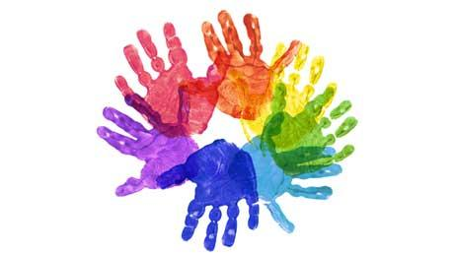 | Through these PSHE units, the children will begin to answer the key questions.  My Emotions  How can we make mental wellbeing a part of daily life? How do I manage strong emotions? How can I judge if my own feelings are appropriate and proportionate? How do I recognise how other people feel and respond to them? How do I get support when things are difficult?  Anti-bullying  Can I explain the differences between friendship difficulties and bullying? Can I define the characteristics and different forms of bullying? How can I be safe online and deal with cyberbullying? How might bullying affect people’s mental wellbeing? Can I identify ways of preventing bullying in school and the wider community?
World Views   | Should we see difference or diversity?  This unit is an introduction to ethics with a focus on Christianity. It starts with an opportunity for the children to reflect on how they make judgements about others, before investigating various examples of situations from history where people have had to choose between treating others badly because of their differences or celebrating diversity. We will explore the question, ‘Is what you do or what you say the most important?’  How can Hindus find out what God is like?  A more in-depth look at sources of information about the idea of god in Hinduism, including murtis, stories, texts and religious practise. It will include looking at the female aspect of god as well as the male; ideas of diversity and inclusiveness within the stories of Krishna and Durga; ideas of incarnation and the environmental aspects of Durga Puja and problems of cultural appropriation of Hindu festivals in modern Western societies.
  Languages | In the unit ‘Les Fruits’, we will name, recognise and remember up to 10 fruits in French. and attempt to spell some of these nouns with their correct article/ determiner. We will learn how to ask somebody in French if they like a particular fruit and say what fruits we like and dislike.
Enrichment  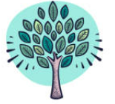 | If you have any expertise relating to any of our units of learning and would be interested in sharing them with the children, please contact the school office.
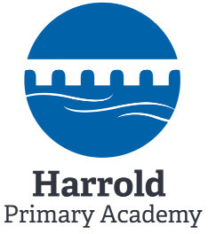 | The children will continue to develop their growth mindset as it leads to a desire to learn and therefore an aptitude to embrace challenges, persist in the face of setbacks, see effort as the path to mastery, learn from criticism and find lessons and inspiration in the success of others. We promote this positive attitude to learning across the curriculum.  This overview gives an outline of the Year 5 autumn term curriculum.
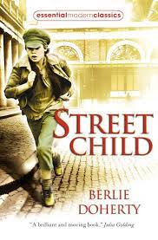  English | Narrative: ‘Street Child’ by Berlie Doherty will be used as a text relating to our Industrial Revolution, History learning. The children will develop their use of literary devices, vocabulary and dialogue. We will also be reading the text ‘Asha and the Spirit Bird’ by Jasbinder Bilan to write some extended pieces of narrative.  Non-Fiction: The children will be writing journalistic pieces and persuasive writing texts linked to other areas of the curriculum.  Poetry: The children will be exploring narrative poems and developing their use of figurative language. Links will be made with Remembrance Day and Anti-Bullying Week in November.  Reading: Children will use high quality stimuli to develop their reading skills. They are exposed to a wide range of text types and encouraged to build their reading stamina.  Spelling: Curriculum spelling rules/patterns and Year 5/6 key words are taught on a two weekly cycle.  Grammar: Children will apply their learning of punctuation and grammar skills throughout all English units.
Maths  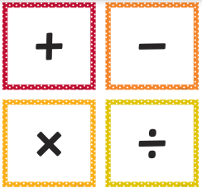 | Year 5  The children will extend their knowledge of place value to numbers up to 1,000,000, including numbers to three decimal places. They will then develop their skills in addition and subtraction using these numbers. Furthermore, they will learn about properties of number, including multiples, factors, square and cubed numbers. Also, they will extend their previous learning of perimeter.  Year 6  The children will extend their knowledge of place value to numbers up to 10,000,000, including numbers to three decimal places They will then develop their skills in the four operations (+, -, x, ÷) using numbers within this range. Also, they will extend their knowledge of fractions, learning to multiply and divide them. They will learn about ratio and proportion and position and direction relating to all four quadrants.
Science  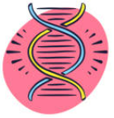 | Earth and Space  The children will be able to describe the movement of the Earth and other planets relative to the Sun in the solar system. In addition to this, they will study the movement of the Moon relative to the Earth as well as look at the Sun, Earth and Moon as approximately spherical bodies. Children will use the idea of the Earth’s rotation to explain day and night and the apparent movement of the Sun across the sky.
History  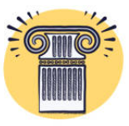 | The Industrial Revolution - What was the significance of the Industrial Revolution on Britain?  The children will dive into the Industrial Revolution in Britain. We will consider the impact this had on the people, industry and lifestyle during the 1800s. Over the unit, children will use sources of evidence to learn about the past, to investigate the growth of the railway, changes in production and the landscape. Along with this, we will be visiting the Black Country Museum to experience the streets and industry of the Victorian period.
Geography   | Asia - Why is this Asia?  In Geography we will be exploring the vast and diverse continent of Asia, looking at both its physical and human geography. The children will undertake map work and use it to compare and contrast different cultures and physical environments from across the continent. This will strengthen their understanding of the world and our place in it as they endeavour to answer the question ‘Why is Asia so diverse?’
Art   | 2D drawing to 3D making  During this pathway, the children will explore how 2D drawings can be transformed to 3D objects, working towards a final sculptural outcome.  Brave Colour  As part of our learning, the children will look at the work of installation artists who use light, form and colour to create immersive environments. We are then hoping to create our own 2D or 3D models to share our vision of imagined installations with others.
Year 5 Autumn Term Curriculum 2023

