  Design and Technology (D.T.) | Cooking and Nutrition – A balanced diet  In this unit of cooking and nutrition, the children will expand their knowledge of healthy eating by designing and making their own healthy pizza. They will look at the nutritional values of ingredients used to make a pizza and develop their grating and chopping skills.
Physical Education  (P.E.)   | Invasion Games – Football  The children will develop their passing and moving skills to keep possession and develop this concept into mini game situations.  Gymnastics – Principles of Balance  This unit focuses on exploring and applying the 3 principles of balance: contact points, surface area and centre of gravity.  Invasion Games – Health Related Exercise  The children will consider how exercise relates to having a healthy lifestyle and mental wellbeing.  Dance – Musical theatre  The children will translate ideas from a variety of stimuli into movement and develop compositional devices to create motifs with a partner.
Computing   | Digital Literacy and E-Safety  The children will learn about cyber bullying, creating safe passwords and communicating safely.
Music   | In Music, the children will learn how to play djembe drums for the term with Bedfordshire Music Hub.
Personal Social Health Education (P.S.H.E.)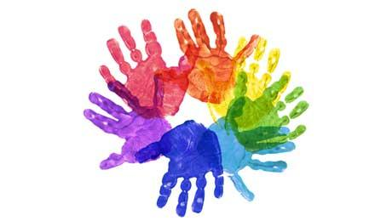 | My Emotions  This unit will help develop children’s understanding and recognition of their own emotions and those of others, including how we might express those feelings. It builds on the work done in the equivalent unit for Years 1 and 2 and the children will identify an increasing range of emotions, developing a language to describe them, and consider what prompts different feelings in themselves and others.  Anti-Bullying  In this unit children will develop their understanding of the key characteristics of bullying and develop, explore and apply definitions of bullying to a range of situations including cyberbullying.  The theme of anti-bullying will be addressed throughout the year, but with a particular focus during Anti-Bullying Week ( Monday 13th - Friday 17th November).
World Views   | Why do people tell creation stories? Do we still need them?  Creation stories fulfil the human need to answer the questions, ‘Where have we come from?’ and ‘Why are we here?’. In this unit we will investigate a wide variety of ideas about creation, including scientific theories, origin stories of the Heiltsuk people of NW Canada and the creation stories in the Abrahamic and Hindu faiths. We will ask, “Are these stories literal or symbolic?”  Symbols of faith – what do they mean to British people today?  This unit looks at signs and symbols through the lenses of two organised worldviews which both hold important festivals in the autumn and winter – Hinduism and Christianity. We will find out about the symbolism of Hindu murtis and how for many people these show different aspects of the one Supreme Being. We will also look at some of the symbols used in Christianity. We will then research diversity in how people celebrate both Divali and Christmas
Languages  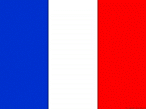 | We will be learning greetings and how to introduce ourselves.  We will then develop our understanding of numbers, colours and animal names.
Enrichment  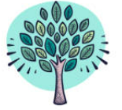 | If you have any expertise relating to any of our units of learning and would be interested in sharing them with the children, please contact the Year 3/4 team through the school office.
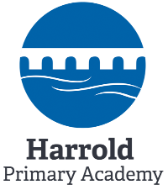 | The children will continue to develop their growth mindset as it leads to a desire to learn and therefore an aptitude to embrace challenges, persist in the face of setbacks, see effort as the path to mastery, learn from criticism and find lessons and inspiration in the success of others. We promote this positive attitude to learning across the curriculum.  This overview gives an outline of the Year 3/4 autumn term curriculum.
English  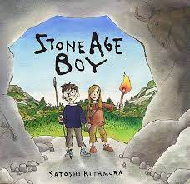 | Descriptive Poetry: This unit aims to develop children’s enjoyment of language and makes links to key phonics learning.  Narrative: The children will be reading ‘Stone Age Boy’ by Satoshi Kitamura to develop their understanding of the Stone Age through an accessible narrative. Later in the term, the children will study ‘Escape from Pompeii’, also linking with their learning in History. These texts will form the stimuli for a range of writing.  Non-fiction: Children will write a non-chronological report to convey information in an engaging way for the reader usuing a range of cohesive devices. They will also write an explanation text linked to other areas of the curriculum.  Reading: Children will use high quality stimuli to develop their reading skills. They are exposed to a wide range of text types and encouraged to build their reading stamina.  Spelling: Curriculum spelling rules and patterns are taught on a weekly cycle.  Grammar: Children will apply their learning of punctuation and grammar skills throughout all English units.
Maths  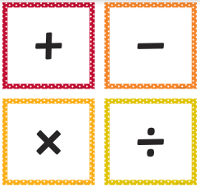 | Year 3  The children will extend their knowledge of place value to numbers up to 1,000. They will then develop their skills in addition and subtraction using these larger value numbers. Then, they will consolidate and extend their recall speed of the multiplication and division facts for the 2, 3, 4, 5, 8 and 10 times tables.  Year 4  The children will extend their knowledge of place value to numbers up to 10,000. They will then develop their skills in addition and subtraction using these larger value numbers. Then, they will consolidate and extend their recall speed of the multiplication and division facts for the 3, 6, 9, 7, 11 and 12 times tables. In Geometry, they will learn about the properties of different triangles and quadrilaterals.
Science  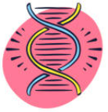 | Rocks, Fossils and Soils  Children will explore a variety of igneous, sedimentary and metamorphic rocks, classifying them based on their appearance and physical properties. Children will discover how fossils were formed and consider soil as a mixture of rocks and organic matter. Children will carry out a wide range of practical, hands-on activities including setting up a comparative test. They will gather and present the results of these practical enquiries through annotated drawings, tables, written conclusions and verbal presentations.  Animals including humans (Skeletons)  Children will identify that humans, and some other animals, have skeletons and muscles for support, protection and movement.
History  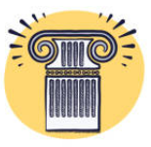 | Stone Age to Iron Age - How did technological developments change life during the Stone Age to Iron Age?  Children will be diving into prehistory and archaeology as we study the Stone Age and look at how early humans transitioned and developed through the Bronze Age, into the Iron Age. Children will use and build their historical skills through the questioning of primary and secondary sources. As well as being given the chance to conduct historical research and answer enquiry questions, they will also be encouraged to compare Prehistory to other time periods. As the children learn about the first tools used by early hominins in the development of farming and the discovery of smelting metal, they will see how human culture started to be shaped. They will learn how the human skeleton has developed from the homo-habilis to homosapiens. Children will also delve into the mystery of stone circles such as Stonehenge and find out about the cave paintings from Lascaux. Moving into the Bronze Age, they will explore how trade and travel impacted on Britain and the advances achieved through the use of copper and bronze.
Geography   | Mountains and Earthquakes – How powerful is our world?  Children will participate in local fieldwork by exploring and completing activities in the school grounds. They will create their own maps with a key to represent the human and physical features in the school environment.
Art   | Gestural Drawing with Charcoal  The children will make loose, gestural drawings with charcoal, and will discover how to make drawings that capture a sense of drama or performance using charcoal.  Cloth, Thread, Paint  Through this pathway the children will explore how artists combine media to create work in response to landscape. They will use acrylic and thread to make a final painted and stitched piece.
Year 3/4 Autumn Term Curriculum 2023

