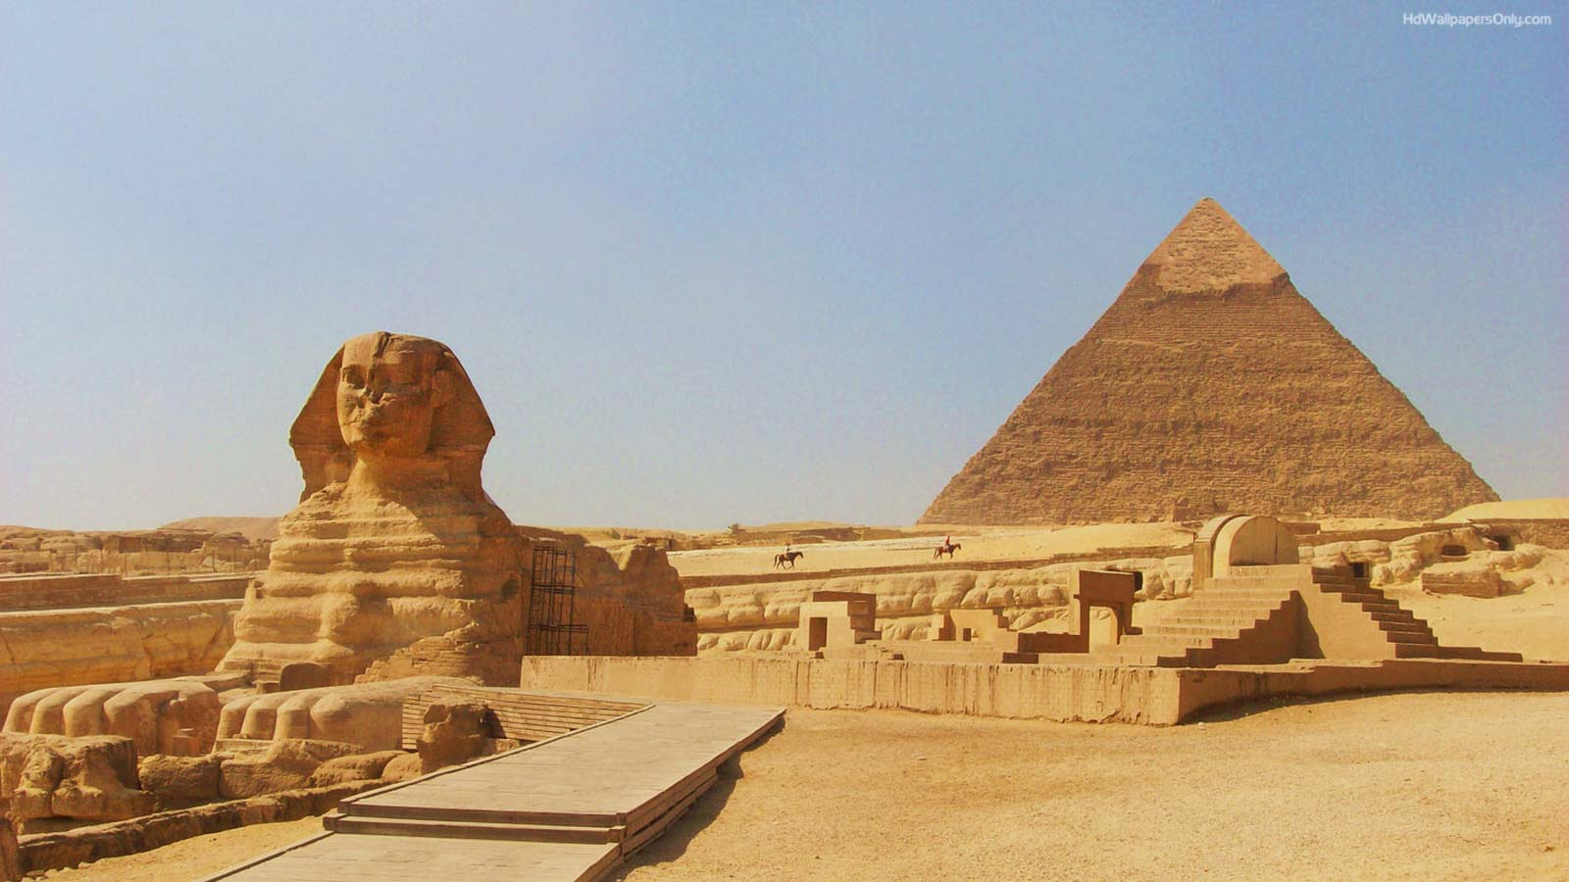
Spellings
There will be a new spelling list coming home each week. Children will need to practise their spellings in their spelling journals ready for their spelling test on Wednesday.

Science
We are studying the topic of Electricity. We will set up simple practical enquiries and fair tests and gather data in a variety of ways to help us to answer questions.

RE/ PSHE
In PSHE, the children will explore their health and wellbeing. In RE, the children will explore the answers to: Why do some people think life is like a journey?
Computing
We will be developing our digital literacy skills. We will also focus on E-Safety and how to stay safe on the internet.

PE
PE lessons will take place on Tuesdays and Wednesdays.Please ensure your child has the correct PE kit and can remove any earrings themselves. We will be outside when the weather permits, so suitable clothing is essential.
Magpies Autumn Term 1
Ancient Egypt
Geography/History
This term we will be studying Ancient Egypt. We will look at physical features, including the importance of the River Nile to the people of Egypt. We will study artefacts to gain an understanding of the life of ordinary people, their methods of farming, worship of gods and writings.
English
In English, we will be using the Egytpian Cinderella as our model text of an adaptation to a traditional tale. We will then adapt our own traditional tale independently.
Art and DT
We will be looking at Egyptian art form and Egyptian painting.

French
In French, we will be learning the numbers, months and days of the week.

Music
This term in music we have Bedford Borough instrumental projects in Magpies to teach djembe drums.
Maths
We will be working on our knowledge of Place Value, and Addition and Subtraction.
The children will practice strategies both mentally and written to solve problems.
There will be on going revision of Timetables both in class and by the use of TT Rockstars.

